**Rapid Application Development-scs2208**

**PHP Assignment (Individual)**

**Report**

This form is for managing vehicle owners in the system for the PALA AUTO TRADERS (PVT) LTD. It contains five pages with functionalities to ADD AN OWNER , VIEW OWNERS , DELET AN OWNER , AND UPDATE OWNER details of a particular vehicle(and a menu page that include a menu to select one of the above functionalities ).

Firstly the user is directed to the index page which contain a menu , and allowes the user to select one of the four functionalities as needed.

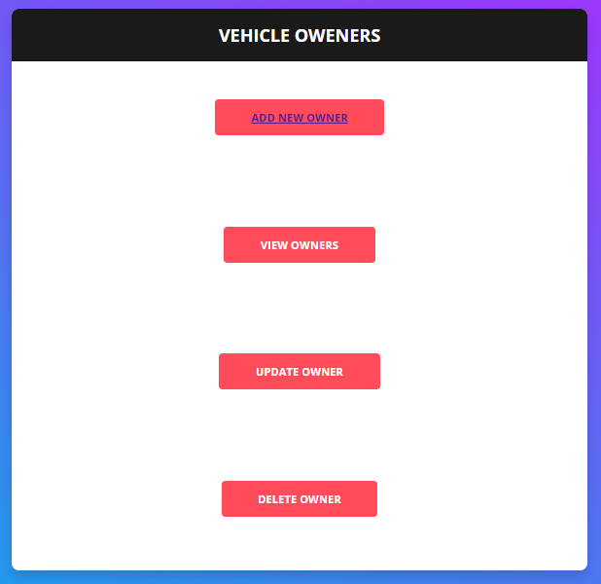

**Add owner**

**If the user selects the add owner option the user is directed to new page which contains a form which allows to input the relevant details t add a new owner**

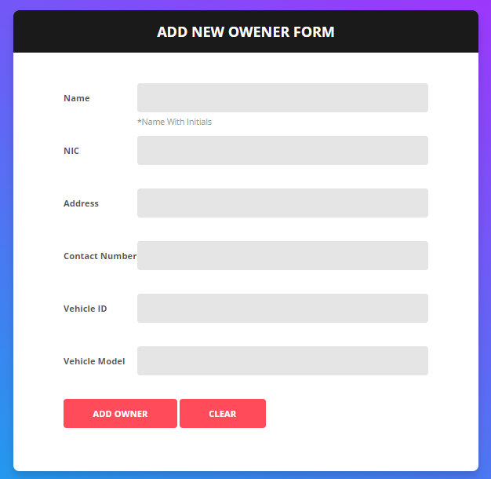

Sql query :-

$sql = "INSERT INTO vehicleowners( Name, NIC, Address, ContactNo, VehicleID, VehicleModel)

VALUES ('$name', '$nic', '$address' , '$contactNo' , '$vehicleId' , '$vehicleModel')";

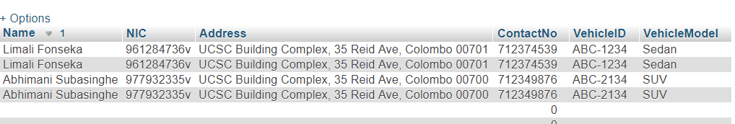

**View owners**

This functionality allows the user to view all the owners that are currently in the database.

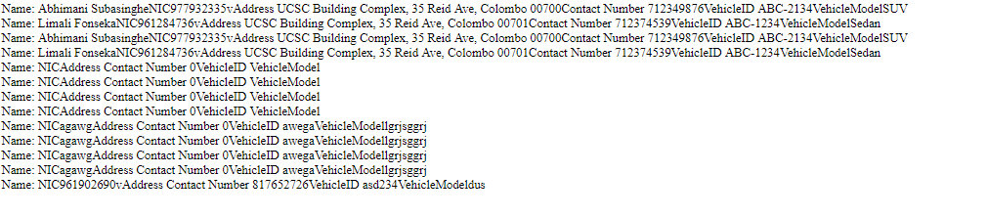

**Update owner**

This functionality allows the user to update details of any owner that is already in the database

**Delete owner**

This option is used to remove the details of any vehicle owner in the databse